**10 top tips for beginners** V.2

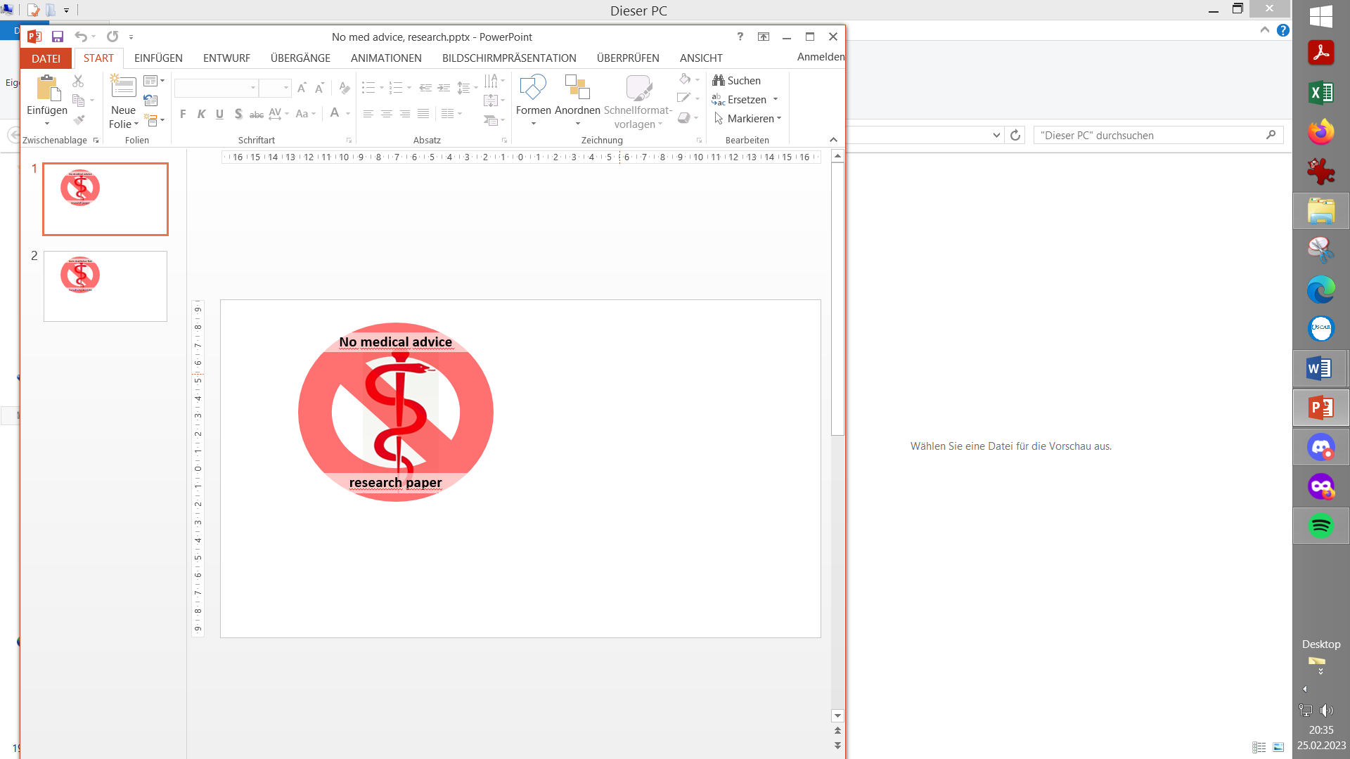

*by: Matthhew Preston, Aug.2019*

I’m now two months into ‘looping’ – using Accu-chek Insight pump, Dexcom G6, xDrip+ and AndroidAPS – and it’s been fantastic. But I’ve also found it hard work to get to grips with, and I thought it might help others starting out if I set down some of what I’ve learned, focusing on ***how* to go about it** rather than on technical specifics.

Some context first: I’m 46 years old, T1D for 16 years, 15 of them on MDI. I started pumping 15 months ago, and full-time with CGM 6 months ago. From there, looping was an obvious step and I don’t regret it for a moment. But I’m not a doctor – well, not the sort of doctor who can help you – and YDMV, so your context and outcomes may well differ. Ditto your hardware and software. I’ve never had to grapple with the challenge of a diabetic child. So here are my top ten tips:

1. Looping requires a functioning and accurate pump and CGM

If your basal rates aren’t right, your CGM isn’t calibrated/accurate, your pump has air bubbles etc etc., looping will not solve these problems, and you might inadvertently choose settings for the loop that make them worse. So I feel I did the right thing using the pump for a year, and CGM for a couple of months, before starting to loop

1. If you’re looking for an automatic pancreas-replacement, think again.

OK, lots of what the loop does is automated and superb, and it does it far better than I could ever do manually. But I think of it more as a self-regulating system than as an automatic one. It can greatly reduce the work and time you spend managing T1D, but it doesn’t eliminate it, certainly at the beginning.

3. You don’t need degrees in maths, computing, physiology and nutritional science …

But you need to develop some understanding of each of them. Maybe others have found it easier than I have, but I won’t kid you: the rewards are easily worth it, but it’s taken me time and effort to get my head round it all.

1. Learning is key

I tried to research, read and understand all the aspects and options of looping/AndroidAPS right from the start. I failed. There was just too much for me to understand as a theoretical exercise. But I have learned as I’ve gone along, and that learning has been key. The system will pay you back ten times over if you understand how it all works, including the curves, the predictions, the various settings etc.

5. You still will see bg highs and lows

I have continued to have (some) bG highs and lows. But while there’s more to get your head  around than when just starting with a pump, physically I’ve found it much easier. Nothing to compare to those hammering hypos while getting the basals right, or getting used to wearing the pump. Conversely I’ve found the rewards – in terms of stable bGs – hugely gratifying and almost immediate.

6. Mindful approach to tuning (to adjusting settings)

Compared to MDI (multiple daily injections), and even to classical a pump therapy, there are LOTS of settings in AndroidAPS. So many opportunities to perfect your set-up, but also to get it wrong!

**Take advice** from the experts: read what all the settings do, and **only change one at a time** and see its effect before making another.

The big change for me was making my Carb Ratio more aggressive, to limit post-meal spikes, and letting the loop zero-temp (ie cutting off basal insulin) to avoid hypoing later on.

7. Use the Objectives to tweek your settings

It’s frustrating how long it takes to work through the Objectives in AndroidAPS (almost 2 months), but they are (*edited:* for the most part) well thought through, (have to cover all relevant topics for all users,) and they exist for our and your safety.

Don’t treat it as time in which you have to wait inertly. Rather use the time you spend in each Objective to tweak the settings that have been unlocked, and to make the new way of operating second-nature.

8. Looping requires some behaviour changes.

In my  case, keeping my phone on or very near my person at all times, taking less sugar than before when going low, and regularly backing up my AndroidAPS settings were new rountines to learn. But on balance the changes have definitely improved my lifestyle: I can now pop to the shops just with my phone and emergency glucose gel; I no longer need a shoulder bag at all times; exercise is easier, and I can now just command everything from the phone that I use in daily life, instead of the monstrosity that is/was the Insight handset etc. And that’s even without the more stable bGs and reduced HbA1C.

9. Feed your loop all relevant info

You need to tell the loop almost everything. OK, maybe not everything, and you don’t 100%  need to. But the more you can tell it the better: the carbs in a snack you’re taking to come out of a hypo, that you’re disconnecting for a few minutes to take a shower etc.

The central calculation the loop is constantly making is how much active insulin you have in you, versus how many carbs you’ve eaten but not yet absorbed. The loop can’t know if the insulin has been pumping onto your duvet while you’re in the shower, or if you are into some sports. Or at least it can’t know nearly as well or as quickly as if you tell it. So do. It’s really very easy.

10. Seek advice, stay in touch

There’s no comprehensive instruction manual for looping, or if there is, I haven’t found it. Indeed, as an adaptive system I doubt it’s possible to write an old-fashioned manual. But there are superb resources out there, amongst which you’ll find the answer to almost every question. I particularly recommend the Wiki (readthedocs) for your software (e.g. AndroidAPS), Dana’s ebook, and the relevant Facebook group(s).

The Search function on each Facebook (or Discord etc) group is particularly useful:

You’re unlikely to be the first person facing the challenge you’re having, so well worth looking up how others dealt with it (and the responses they got) before asking a new question yourself.

11. I said ‘ten top tips’, but here’s a bonus, which I offer tentatively as I’m sure it’s unnecessary. But: be nice, especially on social media! T1D makes us all angry at times, it’s frustrating when something doesn’t work, and the ecosystem we’re working with (pump, CGM, loop software etc.) is complex and so liable to fall over from time to time. But the people who’ve developed this system are modern-day angels, if you ask me, and they deserve all the praise and warmth we can give them. (This is Open Source, remember...) Every night, and particularly every morning, I am more grateful to them than I can express. I hope you will be too.

**More reflections, 2.5 years into my looping journey**

*UPDATE by: Matthhew Preston, Jan.2022*

Two and a half years on from my beginner’s tips above, I thought I’d offer some

further reflections on my experience looping with AAPS. Not so much ‘tips’, but

thoughts which might nonetheless resonate with or even encourage others. Longer

than the last lot, but then I’ve been doing it longer. Here goes...

1. I now consider myself an intermediate-level looper. I’m nowhere near being a

programmer (all hail to you...). I read with interest the wizardry posted by e.g. Tim

Street and Bernd Herpichböhm, but don’t pretend to understand it all. I’m not doing

low-carb, or experimenting with a fully closed loop (no bolusing etc.). But I’m happy

with where I’ve got to, and looping is working for me.

2. The results are outstanding, in my view. Just on the numbers, my HbA1c has

stabilised at 40 mmol/mol (i.e. 5.8%) or just under. I’ve got 89%-90% time in range

(4-10 mmol/L), with very few hypos. My GP has stopped sending me letters warning

me about pre-diabetes (!!!), and even my consultant says that as far as he’s

concerned, I’m a non-diabetic who just takes 50U of insulin each day. I depend on

healthcare professionals for tests and access to supplies – and, please, for another

loopable pump when my Insight dies – but that’s it.

3. With commercial closed loops coming soon, a reminder that for all its

sophistication, AAPS is still a *DIY* closed loop, created and supported by people in

their own time. You’ll have to prise AAPS out of my closed dead hands to put me on

a commercial system, but for those who haven’t the time, inclination or wherewithal

to engage with its complexity, the simplicity of commercial closed looping may well

be for you, when you can get it. I for one won’t be judging you, not that you should

care what I think, or indeed let *anyone* judge you.

4. I’m still using the basic Moto G7 Power phone I bought when I started looping

(under £200). I use it for everything, not just for looping. I had battery problems a

while back, and built into my daily routine a full restart of the phone each morning

after its overnight charge. I don’t know if that’s strictly necessary, but I’ve never run

out of battery since doing that daily.

5. The core tech just works for me now. Apart from the *occasional* dodgy AAA

battery, my Insight has proved rock solid. xDrip is a workhorse: it probably drops

connection or misses readings about once per day or less. When I notice it, I cycle

Airplane mode on and off on my phone, and restart the xDrip collector, which always

fixes it. When I don’t notice it, it usually just rights itself. I’ve got the hang of

updating AAPS, Nightscout etc. I try to resist the lure of building the new version of

AAPS the minute there’s an update – because Milos and co. often release a fresh

version soon afterwards to tidy up the snags which inevitably come to light with a

general release – but my enthusiasm usually gets the better of me.

6. CGM – in my case self-funded Dexcom – remains the foundation stone of

looping and of good diabetes control. For those like me living in the UK, I’m hoping

that the new NICE guidance (thank you, Partha Kar and co.) translates quickly into

NHS-supplied CGM for all of us. Having built up a ‘float’ of spare Dexcom sensors

and transmitters in my first year, through restarting both in the days when it was

easier to do so, I just use each for their 10/100 day-lifespan. I’ve been lucky to have

had very few failures, and I’ve got my ‘float’ for when I do.

7. The other tech is about what works for you. Nightscout is obligatory to get

through the AAPS objectives, but even though I don’t need its remote monitoring

function, I find it surprisingly useful. I haven’t bothered with a watch because I’ve no

need. But having my BG and loop details on my Garmin cycle computer (Edge 820)

is *amazingly* useful. I love the FloatingGlucose program on Windows (from

GitHub), which puts a small window with my BG on top of whatever else I’m doing on

my laptop. Each to their own.

8. I probably spent my first six months on AAPS constantly engaging with it: first

the Objectives, then refining and re-refining my personal settings (basal, IC, ISF and

all the rest). Since those six months, I’ve made very few changes, and then only

after spotting trends over an extended period of time. (Notably strengthening my

breakfast-time IC and ISF, and weakening both even more than before in the time

block *between* lunch and dinner.) I’m not claiming my settings are perfect: if I really

stretched them by eating odd foods and quantities at unusual times of day, I’m sure it

would throw up problems which would need fixing. But for my pattern of life –

especially routine during the pandemic – they’re working well for me.

9. Partial pre-bolusing was the key which unpicked the lock for me. You do you,

but I now pre-bolus 6U about 30-40 minutes before both lunch and dinner.

Sometimes even earlier if my BG is high (8+), though much closer to eating if I’m

under 5. I don’t pre-bolus for breakfast, but then I don’t eat much then.

10. For most meals, I deliver the rest of the bolus (as per the Calculator’s

suggestion) when starting to eat. But for a few types of food – especially chips

(‘fries’) – I announce all the carbs up front but deliberately under-bolus, by as much

as 30%-40%. That avoids post-meal hypos, but still lets the loop ‘catch up’

aggressively with more insulin when it sees BG rises later on. I tried bolusing for fats

and proteins, but it didn’t work for me.

11. I got into the habit of carb-counting rigorously while adjusting my settings (I

*really* recommend that), and have just carried on with that. I use scales where I

can (e.g. for bread and baked potatoes, and before cooking pasta, rice etc.), and

Carbs & Cals on my phone when I can’t. I could probably relax a bit, and I do when

I’m out, but I don’t find it a major inconvenience to weigh my main carbs at home, so

why not? The loop will correct mistakes – given time – but the fewer mistakes it has

to correct the better, in my view.

12. My diet remains healthy but high-carb (about 350g daily, over three meals):

lots of sourdough bread, fruit, home-made pasta and with dinner a good portion of

home-made ice cream. I’m sure T1Ds don’t need to eat like I do, but I love cooking

and eating, so what can I say?!

13. Exercise – cycling, which I also love – remains a challenge but not nearly as

much as it used to be. I have discovered that IOB is the enemy when starting

exercise, so I try to time my rides to start on an empty stomach. I make sure I eat

during exercise, not just to keep my BG up but for fuelling muscles too (a classic

diabetic’s mistake only to do the former, I’m told). BG control *after* exercise can be

harder than during, but nothing which keeping a closer eye on my numbers than

normal can’t solve. (A pot of Waitrose mini-bites in the cupboard – at 8-10g of carbs

per bite – solves most problems, I find....)

14. For all the maths and science involved in looping, I still find there’s room for

judgement and gut instinct: how much to pre-bolus? When? Does this amount of

insulin ‘feel’ right for the circumstances and what’s in front of me? I do think it’s

important not to let the calculations and computerization erase all common sense:

sometimes labels are wrong, your scales may be faulty, you may be super-resistant

or -sensitive to insulin today. I largely let the loop do its thing (e.g. I make very few

manual corrections), but I don’t wholly submit to it and abandon thought.

Moving now from the technical to the social and the psychological....

15. I’ve noticed a real paradox about diabetes and (some) diabetics. With the

tools to manage T1D now increasingly available, I’m convinced that the key to doing

so is *knowledge*, and that learning from and sharing experiences with others is the

best way to gain it. Yet so many of us are tentative or actively reluctant to break

from our established patterns – even if they’re not going well – or to talk about our

diabetes. I was like that myself for 15 years. Even though I’m keen to help and

encourage anyone I can to get into pumps and looping, I try to respect their space

and to make myself available but not to press. One good thing about the AAPS

Objectives is how they forced/encouraged me to keep up the momentum rather than

get stuck in ruts. If these thoughts here can motivate just one person to give it a go,

or to keep deepening their knowledge, then I’ve achieved my goal.

16. Psychologically – I suppose we call it mental health these days – I know I’m

still vulnerable to wobbles, and even to the wheels coming off. Cannula fails – when

I get them – are the most common cause (though not looping’s fault, of course). But

I cope *so* much better with the mental side of T1D than I used to. I now feel on top

of diabetes, rather than it on top of me, and I’ve found my increased knowledge of it

massively empowering. Even when things go wrong, I’m looking to learn from it, not

just melt down. Diabetes is now something I’m interested in, rather or even more

than just something I suffer from. Long may this continue....

17. But while Covid has (quite helpfully, for me) cut back the variables associated

with travel and being out and about, I’ve learned the hard way to plan for failure.

Yes, I can go to the shops with just my phone and an emergency energy gel. But for

any travel, there’s an awful lot to pack ‘just in case’: cannulas, tubing, sensors,

transmitters, insulin, batteries etc etc. Plus enough spares for if stranded anywhere

or forced to self-isolate away from home. I don’t think looping itself adds to the load,

but while it can take much of the stress/load out of managing T1D, it can’t remove it

all.

18. To my surprise, the social side of diabetes has really added to my life. I never

expected to make friends from this disease, least of all one as dear as I have made

and to whose DD I am now proudly godfather. (You know who you are.) It’s only

from time to time that people pose questions I can answer, but I find doing so hugely

rewarding.

19. We hear a lot these days about the evils of the (unregulated) internet. I don’t

deny those. But I’ll end these thoughts where I ended my previous set. Through the

internet, I’ve not just got hold of – at no cost – the Formula One car-equivalent of an

automatic pancreas. I’ve also had the privilege of witnessing and occasionally

interacting with those real modern-day angels I mentioned last time, about whom I

really can’t speak highly enough of. Not just those who’ve developed the system

(Dana, Milos, and others whose names I don’t even know), but others too who go out

of their way regularly to help diabetics and parents-of-diabetics solve the problems

they’re facing (Terry, Navid, etc.). Forgive my sentimentality, but if that doesn’t

reaffirm one’s faith in humanity, I don’t know what will.